**Name: Soh Jian Min**

**Class: DIT/FT/1B/04**

**Admission Number: 2238856**

**Additional Features**

1. **Allow customer to login.**

|  |
| --- |
| Purpose: This feature is to allow customer to login to their account, so that they can check their payment details. |
| Steps   1. Go to <http://localhost:3001/login.html>, login to a customer with email="MARY.SMITH@sakilacustomer.org" and password="Pa$$w0rd"   Graphical user interface  Description automatically generated  Graphical user interface, text, application, email  Description automatically generated |

1. **Allow Customer to view their past payment details.**

|  |
| --- |
| Purpose: This feature is to allow customer to check their payment details more conveniently. By keying the start and end date they can filter their previous payment details. |
| Steps   * 1. Proceed from the home-for-cust page to the cust-pay-detail page by clicking on the “Previous Payment Details” button.    |

1. **Allow admin to search for actor by their name/id.**

|  |
| --- |
| Purpose: This feature is to allow admin to search for an actor conveniently with their preferred way. |
| Steps   * 1. Logout from customer account by clicking the “LOGOUT” button.    |

1. **Allow admin to modify actor’s details.**

|  |
| --- |
| Purpose: This feature is to allow admin to modify actors. (Update/Delete) |
| Steps   * 1. Click on the “Modify Actor” button for actor with id 30.      * 1. Change Actor’s last NAME TO “SOH”, and click on update.    |

1. **Allow admin to search for customer by their name/id.**

|  |
| --- |
| Purpose: This feature is to allow admin to find customer’s information conveniently when they need to check for customer details/if customer exist. |
| Steps   * 1. Click on the “Add Customers” header button, search for customer with substring “Wilson”    |

1. **Allow admin to check customer’s payment details with the start and end date, and customer’s ID.**

|  |
| --- |
| Purpose: This feature is to allow admin to check customer’s payment details. |
| Steps   * 1. Click on “Past Payment Details” on the navigation header. * 1. Choose the start and end date between 31/05/2005 to 30/05/2005 to filter out the payment between the two dates. And type 6 under the “Customer ID” field   Graphical user interface, text, application  Description automatically generated |

**Changes Made To bed_dvd_db**

1. Added password column to customer table and set to not null.

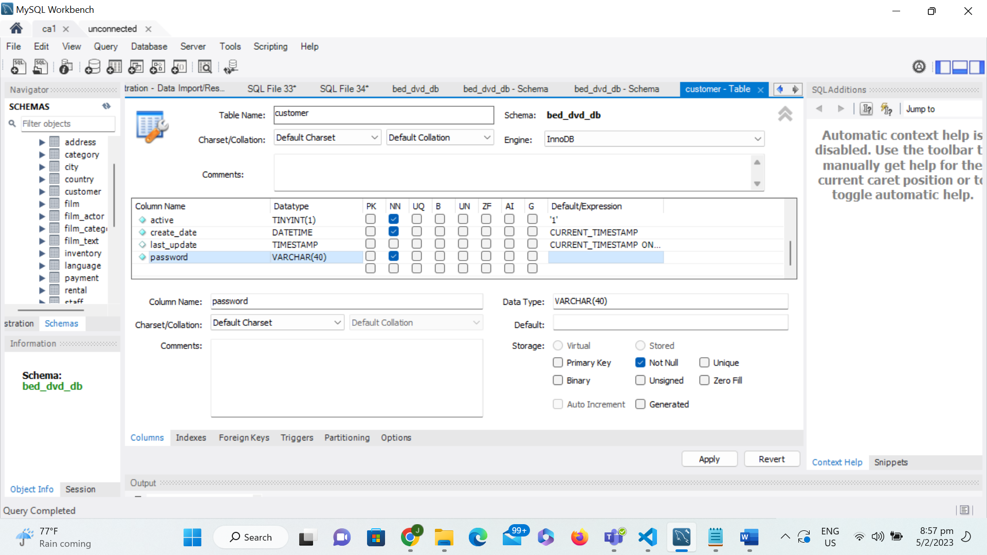

1. Set password column in staff table to not null (Admin)

